

**International School**

**Capstone Project 2**

CMU-SE 451

**Architecture Design**

**Version 1.0**

**Date: 20/02/2024**

Intelligence IT Job Finding - The Recruitment System support with Chatbot

**Submitted by**

**Tuan, Nguyen Anh**

**Dat, Nguyen Thanh**

**Duyet, Pham The**

**Tri, Le Minh**

**Approved by**

**Hoang, Nguyen Thai**

**Proposal Review Panel Representative:**

Name Signature Date

**Capstone Project 2 - Mentor:**

Name Signature Date

**PROJECT INFORMATION**

|  |  |  |  |  |
| --- | --- | --- | --- | --- |
| **Project acronym** | Intelligence IT Job Finding | | | |
| **Project Title** | The Recruitment System support with Chatbot | | | |
| **Start Date** | 15th Feb 2024 | **End Date** | 27th May 2024 | |
| **Lead Institution** | International School, Duy Tan University | | | |
| **Project Mentor** | Mr. Hoang, Nguyen Thai | | | |
| **Scrum master / Project Leader & contact details** | Tuan, Nguyen Anh  Email: tuanquynh1111050102@gmail.com  Tel: 0975523135  ID: 26211235098 | | | |
| **Partner Organization** | Duy Tan University | | | |
| **Project Web URL** |  | | | |
| **Team members** | Name | Email | | Tel |
| 26211242012 | Dat, Nguyen Thanh | nguyendat16111210@gmail.com | | 0352694246 |
| 26211229940 | Tri, Le Minh | leminhtri2002@gmail.com | | 0395967905 |
| 26211233669 | Duyet, Pham The | duyetpham322@gmail.com | | 0705235603 |

**REVISION HISTORY**

|  |  |  |  |  |
| --- | --- | --- | --- | --- |
| **Version** | **Date** | **Comments** | **Author** | **Approval** |
| 1.0 | 20/03/2024 | Update Architecture Design Document | Dat, Nguyen Thanh |  |

**TABLE OF CONTENTS**

Project Information 2

Architecture Document 3

Document Approvals 4

1. Introduction 6

1.1 Project overview 6

1.2 Purpose 6

2. Architecture driver 8

2.1 Business constraints 8

2.2 Technical constraints 8

2.3 Functional requirement 8

2.4 Quality attributes 8

2.4.2.1 Security 9

2.4.2.2 Performance 10

2.4.2.3 Usability 11

2.4.2.4 Correctness 13

2.4.2.4 Modifiability 14

3. Architecture overview 15

3.1 System context 15

3.2 Component and connector 17

3.3 Sequence diagram 20

3.4 Module view 27

3.5 Allocation view 29

4. ATAM 32

4.1 Present the ATAM 32

4.2 Present the business Drivers 32

4.3 Present the Architecture 32

4.4 Identify the Architecture approaches 33

4.5 Create a Quality Attribute Tree 34

4.6 Analyze the Architectural approaches 34

4.7 Brainstorm and prioritize scenarios 35

4.8 Re-analyze the architectural approaches 35

4.9 Present the results 35

5. References: 36

# Introduction

## Project overview

This project develops an advanced recruitment website, integrating the function of suggesting candidates that match the employer's requirements. In addition, it also provides suitable job suggestions based on the candidate's assessment score. This helps optimize the recruitment process and improve the quality of human resources in the recruitment system.

## Purpose

This specification covers following:

* Brief specification of the project, high level requirement.
* Detail business constraint, technical constraint, use case entities, operational use case, quality attribution.
* System context.
* Architecture presented by various view types: Component and Connect view, Module view and Allocation view.
* Evaluate of system architecture documents based on ATAM.
  1. **Business driver**

**Business Problems:**

Employers are facing the challenge of making the recruitment process more efficient, especially in evaluating and selecting suitable candidates for each job position. The process of reviewing and sorting CVs from candidates requires a lot of time and effort, and can also lead to an ineffective selection process.

Limitations of traditional recruitment methods:

● Time and Effort: The process of reviewing a series of CVs requires a lot of time and effort from the employer. There is a possibility of missing out on potential candidates due to the manual selection process.

● Quality and Compatibility: Risk of selecting candidates who are not suitable or do not meet the specific requirements of the job position.

● Recruitment cost: Recruitment costs can increase due to the large amount of time and effort invested in the candidate selection process.

**Business Need:**

Need a system to automate the process of analyzing CVs and suggesting candidates for each position to reduce the work burden on employers. The user interface should be designed to facilitate entering requisitions and viewing suggested candidates. The goal is to optimize recruiters' time and capacity, providing a useful tool to help them quickly find suitable candidates.

# Architecture driver

## 2.1 Business constraints

* Sources: 4 people.
* Project was started on: 19/02/2024.
* Project will be ended on: 26/05/2024.
* Project will be finished in 98 days.
* Cost: $4600.

## 2.2 Technical constraints

**Technical to develop:**

* Programming Language: JavaScript, Python.
* Frameworks: ReactJS, NodeJS, Rasa
* Libraries: RTK - Query, TailwindCSS, MaterialUI, ExpressJS, Mongoose, JWT, socket.io
* Database Management System: MongoDB.

**Environment:**

* Web browsers: Google Chrome, FireFox, Microsoft Edge.
* Operation systems: Microsoft Windows 10.

**2.3 Use Case Entities**

|  |  |
| --- | --- |
| **ID** | E01 |
| **Title** | Admin |
| **Description** | Administrator is responsible for managing the entire system. |
| **Provides**  **Assumptions** | Admin is responsible for the management of the entire system. |
| **Requires**  **Assumptions** | Already have a default admin account. |
| **Identified Use**  **Cases** | UC01: Authentication  UC02: Dashboard view  UC03: Manage job  UC04: Manage candidate  UC05: Manage employer  UC06: Manage category job  UC07: Chatbot Dashboard |

|  |  |
| --- | --- |
| **ID** | E02 |
| **Title** | Employer |
| **Description** | Employer is responsible for managing job postings and related activities. |
| **Provides**  **Assumptions** | Employers interact with the system to post jobs and perform related actions. |
| **Requires**  **Assumptions** | Employers need to register for the employer channel and log in to post recruitment jobs on the "Smart Recruitment System". |
| **Identified Use**  **Cases** | UC08: Authentication  UC09: Dashboard view  UC10: Manage job posting  UC11: Analysis CV and Recommendation  UC12: Contact message |

|  |  |
| --- | --- |
| **ID** | E03 |
| **Title** | Candidate |
| **Description** | Candidates are responsible for searching for jobs on the system and submitting their application. |
| **Provides**  **Assumptions** | The candidate interacts with the system as a job seeker. |
| **Requires**  **Assumptions** | Candidates can search for jobs but need to register and log in to submit job applications on the system. |
| **Identified Use**  **Cases** | UC13: Authentication  UC14: Manage profile  UC15: Search, filter, and view job  UC16: Apply job  UC17: Contact message  UC18: Write CV online  UC19: Contact Chatbot  UC20: Evaluate suitable job |

**2.4 Operational Use Case**

|  |  |
| --- | --- |
| **ID** | UC01 |
| **Title** | Authentication (Login and Logout) |
| **Description** | Authenticate and access the system and then log out. |
| **Entities Involved** | E01 |
| **Precondition** | Admin is already provided with a default account. |
| **Primary Flow** | 1. The administrator visits the Website Link of the Administration System.  2. The administrator navigates to the Admin Login page.  3. The administrator fills out the login form with the default admin account (Email/Password).  4. The administrator clicks the "Login" button.  5. The system authenticates the administrator and grants access to the system.  6. The administrator performs various tasks within the system.  7. When the administrator is done, they navigate to the "Logout" option.  8. The system logs the administrator out. |
| **Post Conditions** | The administrator is logged into the system with their default account (Step 5), and they are successfully logged out (Step 8). |
| **Alternate Flows** | - In step 4 of the Primary Flow, if either the [Email] or [Password] is incorrect, the system will prompt the administrator with an error message such as "Incorrect email or password" or "Incorrect username or password," respectively.  - At steps 1, 2, or 3 of the Primary Flow, if the system crashes or encounters an error, an error message will be displayed to the administrator. |

|  |  |
| --- | --- |
| **ID** | UC02 |
| **Title** | Dashboard View |
| **Description** | View the dashboard of the system. |
| **Entities Involved** | E01 (Admin) |
| **Precondition** | Admin is already logged into the system. |
| **Primary Flow** | 1. The administrator is already logged into the system.  2. The administrator clicks on the "Dashboard" option.  3. The system retrieves and displays key performance indicators and data on the dashboard.  4. The administrator can view graphs, charts, and statistics related to system activities.  5. The administrator can interact with the data and access more detailed information as needed. |
| **Post Conditions** | The administrator has viewed and interacted with the system dashboard. |
| **Alternate Flows** | - In step 3, if there is a data retrieval error, the system redirects to a custom 404 error page. |

|  |  |
| --- | --- |
| **ID** | UC03 |
| **Title** | Manage Job |
| **Description** | Admin manages job postings. |
| **Entities Involved** | E01 (Admin) |
| **Precondition** | Admin is already logged into the system. |
| **Primary Flow** | 1. The administrator is already logged into the system.  2. The administrator navigates to the "Manage Job" section.  3. The system displays a list of existing job postings.  4. The administrator selects a job posting for management.  5. The administrator can perform various tasks such as editing, disabling, or deleting the selected job posting. |
| **Post Conditions** | The administrator has managed the selected job posting. |
| **Alternate Flows** | - In step 4, if the selected job posting is not found, the system redirects to a custom 404 error page. |

|  |  |
| --- | --- |
| **ID** | UC04 |
| **Title** | Manage Candidate |
| **Description** | Admin manages candidate profiles. |
| **Entities Involved** | E01 (Admin) |
| **Precondition** | Admin is already logged into the system. |
| **Primary Flow** | 1. The administrator is already logged into the system.  2. The administrator navigates to the "Manage Candidate" section.  3. The system displays a list of candidate profiles.  4. The administrator selects a candidate profile for management.  5. The administrator can perform various tasks such as viewing, editing, or removing the selected candidate profile. |
| **Post Conditions** | The administrator has managed the selected candidate profile. |
| **Alternate Flows** | - In step 4, if the selected candidate profile is not found, the system redirects to a custom 404 error page. |

|  |  |
| --- | --- |
| **ID** | UC05 |
| **Title** | Manage Employer |
| **Description** | Admin manages employer profiles. |
| **Entities Involved** | E01 (Admin) |
| **Precondition** | Admin is already logged into the system. |
| **Primary Flow** | 1. The administrator is already logged into the system.  2. The administrator navigates to the "Manage Employer" section.  3. The system displays a list of employer profiles.  4. The administrator selects an employer profile for management.  5. The administrator can perform various tasks such as viewing, editing, or removing the selected employer profile. |
| **Post Conditions** | The administrator has managed the selected employer profile. |
| **Alternate Flows** | - In step 4, if the selected employer profile is not found, the system redirects to a custom 404 error page. |

|  |  |
| --- | --- |
| **ID** | UC06 |
| **Title** | Manage Category Job |
| **Description** | Admin manages job categories. |
| **Entities Involved** | E01 (Admin) |
| **Precondition** | Admin is already logged into the system. |
| **Primary Flow** | 1. The administrator is already logged into the system.  2. The administrator navigates to the "Manage Category Job" section.  3. The system displays a list of job categories.  4. The administrator selects a category for management.  5. The administrator can perform various tasks such as adding, editing, or deleting job categories. |
| **Post Conditions** | The administrator has managed the selected job category. |
| **Alternate Flows** | - In step 4, if the selected job category is not found, the system redirects to a custom 404 error page. |

|  |  |
| --- | --- |
| **ID** | UC07 |
| **Title** | Chatbot Dashbord |
| **Description** | Administrators use the dashboard to manage settings and interact with Chatbots in the system. |
| **Entities Involved** | E01 (Admin) |
| **Precondition** | Admin is already logged into the system. |
| **Primary Flow** | 1. The administrator has logged in to the system.  2. Admin navigates to the "Chatbot Dashboard" section.  3. Dashboard display system for Chatbot.  4. Administrators can perform tasks such as talk your chatbot, conversations, data train such as NLU, stories, rules, domains related to Chatbot. |
| **Post Conditions** | The administrator has successfully managed the Chatbot dashboard. |
| **Alternate Flows** | In step 4, if the selected console is not found, the system redirects to a custom 404 error page. |

|  |  |
| --- | --- |
| **ID** | UC08 |
| **Title** | Authentication (Login and Registration) |
| **Description** | Authenticate and access the system or register if no account exists. |
| **Entities Involved** | E02 (Employer) |
| **Precondition** | The user or employer is interacting with the system. |
| **Primary Flow** | 1. User or employer accessing the website.  2. The system checks to see if the user is logged in.  3. If you are not logged in, the system displays the following options:  - If the user already has an account, they can click on the "Sign in" option.  - If the user does not have an account, he or she can click on the "Register" option.  4. When the user logs in, the system will check if your account has registered for the employer channel  - If the account has previously registered for a business account, it will be redirected to the "Dashboard View" page.  - If the account has previously registered for a business account, it will be navigated to the "employer registration" form page  5. Once registered, you will be navigated to the "Dashboard View" page.  6. At any time, the user or employer can select the “Log Out” option to log out of the system. |
| **Post Conditions** | The user or employer is logged into the system or registered |
| **Alternate Flows** | - In step 4, if the entered credentials are incorrect, the system displays an error message. |

|  |  |
| --- | --- |
| **ID** | UC09 |
| **Title** | Dashboard View |
| **Description** | View the dashboard of the system. |
| **Entities Involved** | E02 (Employer) |
| **Precondition** | The employer is already logged into the system. |
| **Primary Flow** | 1. The employer is already logged into the system.  2. The employer clicks on the "Dashboard" option.  3. The system retrieves and displays key performance indicators and data on the dashboard.  4. The employer can view graphs, charts, and statistics related to job postings and candidate applications.  5. The employer can interact with the data and access more detailed information as needed. |
| **Post Conditions** | The employer has viewed and interacted with the system dashboard. |
| **Alternate Flows** | - In step 3, if there is a data retrieval error, the system redirects to a custom 404 error page. |

|  |  |
| --- | --- |
| **ID** | UC10 |
| **Title** | Manage Job Posting |
| **Description** | Employer manages job postings. |
| **Entities Involved** | E02 (Employer) |
| **Precondition** | The employer is already logged into the system. |
| **Primary Flow** | 1. The employer is already logged into the system.  2. The employer navigates to the "Manage Job Posting" section.  3. The system displays a list of existing job postings created by the employer.  4. The employer selects a job posting for management.  5. The employer can perform various tasks such as editing, updating, or removing the selected job posting. |
| **Post Conditions** | The employer has managed the selected job posting. |
| **Alternate Flows** | - In step 3, if there is a data retrieval error, the system redirects to a custom 404 error page. |

|  |  |
| --- | --- |
| **ID** | UC11 |
| **Title** | Analysis CV and Recommendation |
| **Description** | The employer oversees candidate profiles and applications. |
| **Entities Involved** | E02 (Employer) |
| **Precondition** | The employer is already logged into the system. |
| **Primary Flow** | 1. The employer is already logged into the system.  2. The employer navigates to the "Candidate Recommendation" section.  3. The system displays a list of candidate profiles and job applications received by the employer.  4. The employer selects a candidate profile or job application for management.  5. The employer performs various tasks such as viewing, contacting, or shortlisting the selected candidate. |
| **Post Conditions** | The employer has successfully managed the selected candidate profile or job application. |
| **Alternate Flows** | - In step 3, if there is a data retrieval error, the system redirects to a custom 404 error page. |

|  |  |
| --- | --- |
| **ID** | UC12 |
| **Title** | Contact Message |
| **Description** | Candidate and employer send messages to each other. |
| **Entities Involved** | E02 (Employer), E03 (Candidate) |
| **Precondition** | The employer or candidate is already logged into the system. |
| **Primary Flow** | 1. The employer or candidate is already logged into the system.  2. The employer or candidate navigates to the "Contact Message" section.  3. The system displays a messaging interface.  4. The employer or candidate selects a conversation or initiates a new one.  5. The employer or candidate can send and receive messages. |
| **Post Conditions** | Messages have been sent or received in the conversation. |
| **Alternate Flows** | - In step 3, if there is a data retrieval error, the system redirects to a custom 404 error page. |

|  |  |
| --- | --- |
| **ID** | UC13 |
| **Title** | Authentication (Login, Register, Forgot Password, Reset Password, Logout) for Candidate |
| **Description** | Candidate authentication and account management. |
| **Entities Involved** | E03 (Candidate) |
| **Precondition** | The candidate is interacting with the system. |
| **Primary Flow** | 1. The candidate visits the website.  2. The system checks if the candidate is already logged in.  3. If not logged in, the system presents authentication options:  a. If the candidate already has an account, they can click on the "Login" option.  b. If the candidate does not have an account, they can click on the "Register" option.  c. If the candidate has forgotten their password, they can click on the "Forgot Password" option.  4. If the candidate selects "Login," the system displays the login form.  5. The candidate enters their credentials and clicks the "Login" button.  6. The system authenticates the candidate and grants access.  7. If the candidate selects "Register," they are directed to the registration form.  8. The candidate submits the registration form.  9. The system registers the candidate as a new user.  10. If the candidate selects "Forgot Password," they are directed to the password reset form.  11. The candidate provides their email for password reset and submits the form.  12. The system sends a password reset email to the candidate.  13. The candidate receives the email and follows the link to reset their password.  14. The candidate sets a new password.  15. If the candidate is done with their session, they can select the "Logout" option to log out of the system. |
| **Post Conditions** | The candidate is logged into the system or has registered, reset their password, or logged out, as appropriate. |
| **Alternate Flows** | - In step 5, if the entered credentials are incorrect, the system displays an error message.  - In step 8, if there is an error during registration, the system displays a registration error message.  - In steps 11-14, if the password reset process encounters an issue, the system displays an error message. |

|  |  |
| --- | --- |
| **ID** | UC14 |
| **Title** | Manage Profile for Candidate |
| **Description** | Candidate manages their personal profile. |
| **Entities Involved** | E03 (Candidate) |
| **Precondition** | The candidate is already logged into the system |
| **Primary Flow** | 1. The candidate is already logged into the system.  2. The candidate navigates to the "Manage Profile" section.  3. The system displays the candidate's profile for editing.  4. The candidate can update personal information, education, experience, and other profile details.  5. The candidate saves the changes made to their profile. |
| **Post Conditions** | The candidate's personal profile has been updated. |
| **Alternate Flows** | - In step 3, if there is a data retrieval error, the system redirects to a custom 404 error page. |

|  |  |
| --- | --- |
| **ID** | UC15 |
| **Title** | Search, Filter, and View Job |
| **Description** | Candidate searches, filters, and views job listings. |
| **Entities Involved** | E03 (Candidate) |
| **Precondition** | Candidate do not need to log in to the system. |
| **Primary Flow** | 1. The candidate is already logged into the system.  2. The candidate navigates to the "Search Categories" section.  3. The system displays a job search interface.  4. The candidate enters search criteria, applies filters, sort, and view detail a job search.  5. The system retrieves and displays job listings based on the candidate's criteria.  6. The candidate can view job details and apply to job listings. |
| **Post Conditions** | The candidate has searched for and viewed job listings. |
| **Alternate Flows** | - In step 3, if there is a data retrieval error, the system redirects to a custom 404 error page. |

|  |  |
| --- | --- |
| **ID** | UC16 |
| **Title** | Apply Job |
| **Description** | Candidate applies to a job listing. |
| **Entities Involved** | E03 (Candidate) |
| **Precondition** | The candidate is already logged into the system and has viewed a job listing. |
| **Primary Flow** | 1. The candidate has logged into the system and viewed the job listing.  2. Candidates select the list of jobs they want to apply for.  3. The system displays detailed job list.  4. Candidates click on the "Apply" button.  5. Candidates must submit their application including CV in PDF format.  6. The system confirms the application submission. |
| **Post Conditions** | Candidate has applied to the job listing. |
| **Alternate Flows** | - In step 3, if job listing details are not found, the system will redirect to a custom 404 error page. |

|  |  |
| --- | --- |
| **ID** | UC18 |
| **Title** | Write CV Online |
| **Description** | Candidate creates or updates their CV online. |
| **Entities Involved** | E03 (Candidate) |
| **Precondition** | The candidate is already logged into the system. |
| **Primary Flow** | 1. Candidate has logged into the system.  2. Candidates go to the "Write CV Online" section.  3. The system displays the online CV editor.  4. Candidates can enter, edit, and format their CV information.  5. Candidates save their CV to their profile and download it as PDF. |
| **Post Conditions** | Candidates have created or updated their CV online. |
| **Alternate Flows** | - In step 3, if a data retrieval error occurs, the system will redirect to the custom 404 error page. |

|  |  |
| --- | --- |
| **ID** | UC19 |
| **Title** | Contact Chatbot |
| **Description** | Candidates use the contact feature to interact with Chatbot in the system to ask consulting questions. |
| **Entities Involved** | E03 (Candidate) |
| **Precondition** | The candidate is already logged into the system. |
| **Primary Flow** | 1. The candidate has logged into the system.  2. Candidates access the chat box on the bottom right corner of the screen.  3. The system opens a communication channel with Chatbot so candidates can ask questions or receive support. |
| **Post Conditions** | The candidate has successfully interacted with the Chatbot |
| **Alternate Flows** | In step 3, if the system cannot open a communication channel with the Chatbot, it will display the corresponding error message. |

|  |  |
| --- | --- |
| **ID** | UC20 |
| **Title** | Evaluate Suitable Job |
| **Description** | The system evaluates and suggests suitable jobs for the candidate. |
| **Entities Involved** | E03 (Candidate) |
| **Precondition** | The candidate is already logged into the system and has a profile. |
| **Primary Flow** | 1. The candidate is already logged into the system and has a profile.  2. The system assess the candidate's qualifications, skills, and preferences.  3. The system generates a list of job listings that are a good match for the candidate.  4. The candidate can view the suggested jobs and decide whether to apply or explore further. |
| **Post Conditions** | The candidate has received and reviewed suggested job listings. |
| **Alternate Flows** | - In step 2, if there is error, the system may not be able to evaluate suitable jobs, and an error message may be displayed. |

## 

## 2.4 Quality attributes

**2.4.1 Utility table**

There are following quality attributes that drive the design of architecture. Each quality attribute scenario is ranked with importance (I) defined by the Product Owner, and the estimated level difficulty (D). Both values are based on a scale of High (H) - Medium (M) - Low (L).

**2.4.2 Quality attributes**

#### 2.4.2.1 Security

|  |  |
| --- | --- |
| **Scenario:** When an employer initiates an online payment to upgrade their job posting package using VNPay. | |
| **Type** | Security |
| **Stimulus** | Upgrade job posting package |
| **Source of stimulus** | Employer |
| **Environment** | In runtime |
| **Artifact stimulated** | Process online payment using VNPay |
| **Response** | Confirmation code sent to phone |
| **Response measure** | Ensure secure and authenticated payment, integrate with VNPay API, and update the employer's job posting package upon successful payment. |

|  |  |
| --- | --- |
| **Scenario:** When a user registers, their account information is securely stored in the system. | |
| **Type** | Security |
| **Stimulus** | Register |
| **Source of stimulus** | User |
| **Environment** | In runtime |
| **Artifact stimulated** | The system |
| **Response** | Store user account information securely |
| **Response measure** | Encrypt and securely store the user's registration information, including the password, using appropriate security measures.encrypted password. |

#### 

|  |  |
| --- | --- |
| **Scenario:** When a user logs in, their access permissions are determined based on their role (Candidate, Employer, Admin). | |
| **Type** | Security |
| **Stimulus** | Login |
| **Source of stimulus** | User |
| **Environment** | In runtime |
| **Artifact stimulated** | The system |
| **Response** | Authenticate user and assign appropriate access permissions |
| **Response measure** | Access permissions granted based on the user's role, authenticated using JWT (JSON Web Token) with encrypted password. |

#### 2.4.2.2 Performance

|  |  |
| --- | --- |
| **Scenario:** Candidate can search for IT jobs and apply filters quickly without experiencing delays on the job recruitment website. | |
| **Type** | Performance |
| **Stimulus** | Search for IT jobs and apply filters |
| **Source of stimulus** | Candidate |
| **Environment** | In runtime |
| **Artifact stimulated** | The system |
| **Response** | Retrieve and display relevant job listings based on search criteria and applied filters |
| **Response measure** | Ensure that the entire process, including search and filter application, takes less than 5 seconds. |

#### 2.4.2.3 Usability

|  |  |
| --- | --- |
| **Scenario:** Users access the system by logging in with their Google, Facebook accounts. The application allows access with this email account in both ways. | |
| **Type** | Usability |
| **Stimulus** | Access the system by logging in with Google or Facebook accounts |
| **Source of stimulus** | Users |
| **Environment** | In runtime |
| **Artifact stimulated** | The system |
| **Response** | Allows access with this Google or Facebook accounts |
| **Response measure** | Successful login and access using both Google and Facebook accounts |

|  |  |
| --- | --- |
| **Scenario:** Candidate can easily discover suitable jobs through the job recommendation feature and rate the relevance of jobs. | |
| **Type** | Usability |
| **Stimulus** | Utilize the job recommendation feature and rate the relevance of jobs |
| **Source of stimulus** | Candidate |
| **Environment** | The system |
| **Artifact stimulated** | The system |
| **Response** | Percentage of Personal Profile and Job Match based on experience, skills and other factors |
| **Response measure** | Percentage of Personal Profile and Job Match based on experience, skills, and other factors |

|  |  |
| --- | --- |
| **Scenario:** The staff will check the tourist ticket quickly via the QR code sent when payment is successful or the ticket information at the tourist’s email | |
| **Type** | Usability |
| **Stimulus** | Analyze candidate resumes and evaluate the relevance of candidates |
| **Source of stimulus** | Employers |
| **Environment** | In runtime |
| **Artifact stimulated** | The system |
| **Response** | Percentage of CV and job match based on experience, skills and other factors |
| **Response measure** | Percentage of CV and job match, evaluated instantly for timely decision-making in the hiring process. |

#### 2.4.2.4 Modifiability

|  |  |
| --- | --- |
| **Scenario:** The product manager aims to enhance the user experience by allowing employers to customize and beautify their recruitment pages when upgrading their recruitment packages. | |
| **Type** | Modifiability |
| **Stimulus** | Customize and beautify recruitment pages when upgrading recruitment packages |
| **Source of stimulus** | Employer |
| **Environment** | The next version |
| **Artifact stimulated** | The system |
| **Response** | Allows for customization and beautification of recruitment pages |
| **Response measure** | Increase in user satisfaction scores, decrease in bounce rates |

# 

# Architecture overview

This section shows the diagrams which bounds our target system and describes the architecture and interaction between components

## 3.1. System context

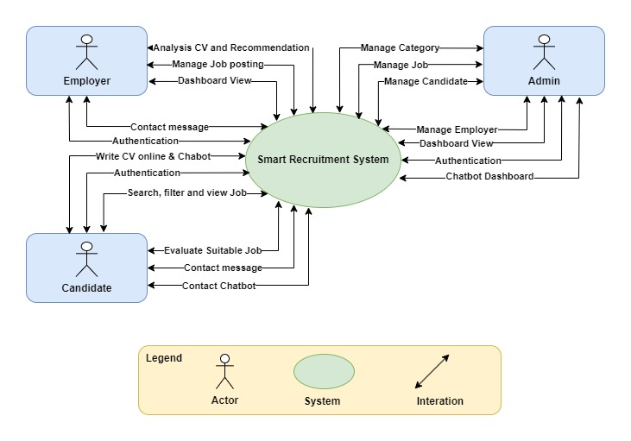

**Figure 1*:*** *System Context Overview*

**Administrator has the responsibility to:**

* Authentication
* Dashboard view
* Manage job
* Manage candidate
* Manage employer
* Manage category job
* Chatboard Dashboard

**Employer has the responsibility to:**

* Authentication
* Dashboard view
* Manage job posting
* Analysis CV and Recommendation
* Contact message

**Candidate has responsibility to:**

* Authentication
* Search, filter and view job
* Apply job
* Contact message
* Write CV online
* Evaluate suitable job
* Contact Chatbot

## 3.2 Component and connector

We mainly used a C&C view to argue and reason about architectural properties, quality attribute requirements, and functional requirements that the system must add here.

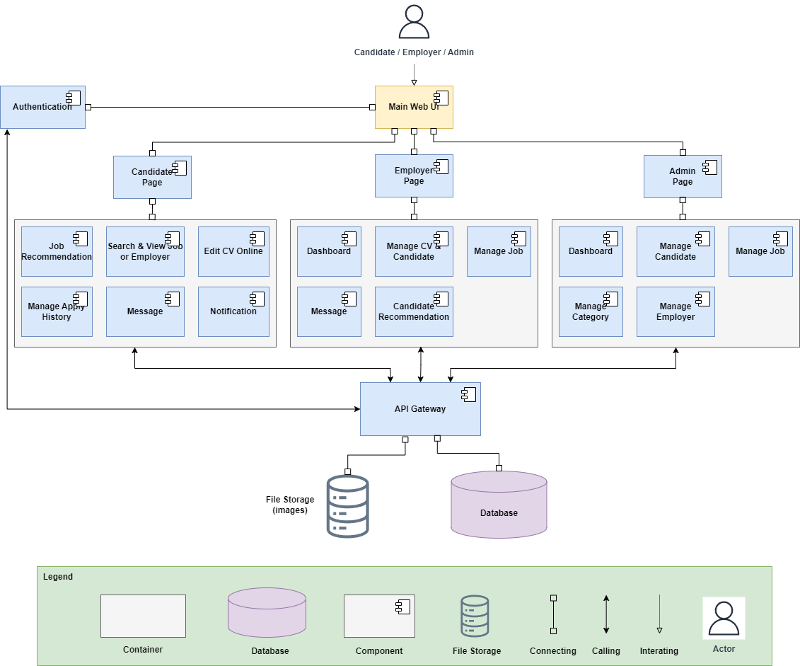

**Figure 2:** *C&C View for Intelligence IT Job Finding*

**Prose**

|  |  |
| --- | --- |
| **Element** | **Responsibilities** |
| Web UI | Web Service is a component that manages and performs activities related to retrieval and storage of data |
| Container | Provides an environment for the deployment and execution of various components within the system. |
| Component | Represents modular and reusable units of functionality within the system, each responsible for specific tasks or features. |
| Connecting | Facilitates communication and interaction between different components and elements within the system. |
| File Storage | Manages the storage and retrieval of files and documents within the system. |
| Database | Database is a component which contains information of users, job, apply, resume, payment histories, ... All data the system needs |
| API Gateway | HTTP protocol used to help client and server interact with together based REST architect |

## 

## 

## Description

The web client sends and receives data from the server through the web service API. User operations will send requests to the server through the API, the server will process the data with the corresponding models and access the database to retrieve data, then respond to the information to the web client through the API to display it to the user

## 3.4 Module view

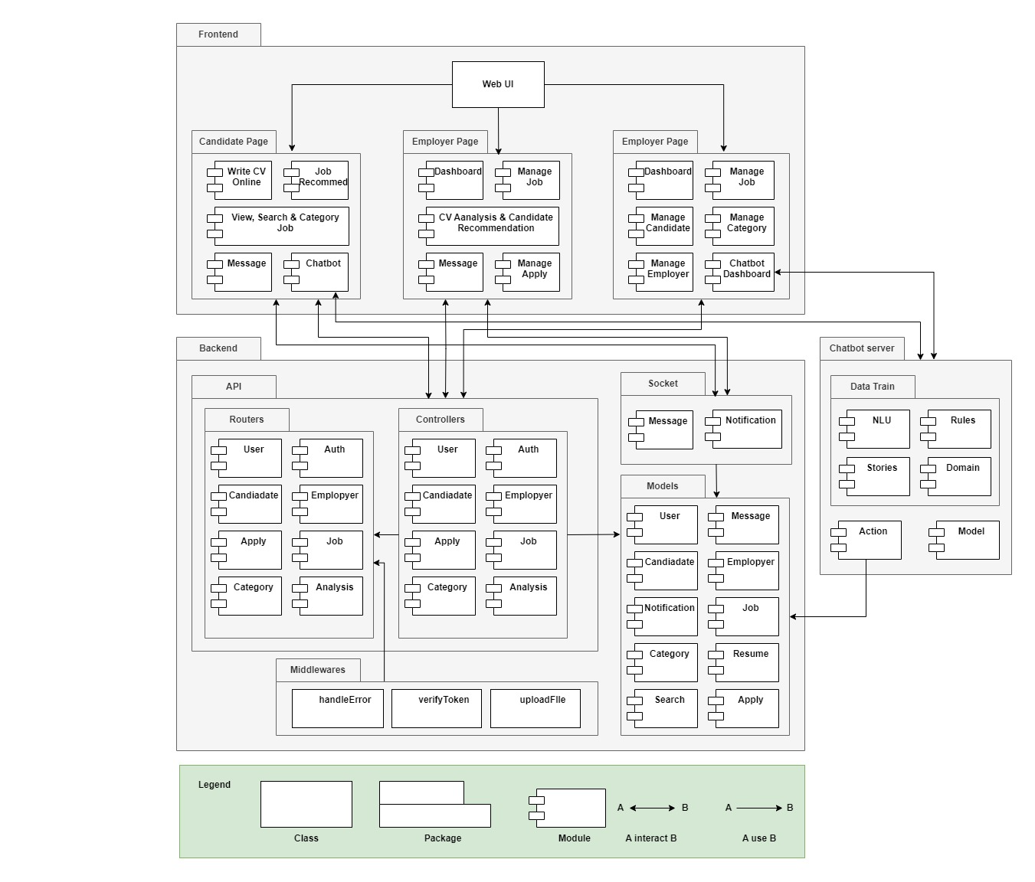

**Figure 3:** *Module View for Intelligence IT Job Finding*

**Prose**

|  |  |
| --- | --- |
| **Element** | **Responsibilities** |
| Web View | The website package contains management modules for admin, employer and candidate. |
|  |  |
|  |  |
|  |  |
| Models | Package used to define schemas for collection in the database |
| Controller | Package contains logic of APIs for modules in the system |

**Description**

The system implement according to client-server architecture and includes 3rd party services. After users interact with UI and send request to server. Server get and handle request, perform tasks through Controller, Model, Router package and send response to Client to display result on UI.

## **3.5 Allocation view**

The allocation view models the run-time architecture of a system. It shows the configuration of the hardware elements when the system is deployed.

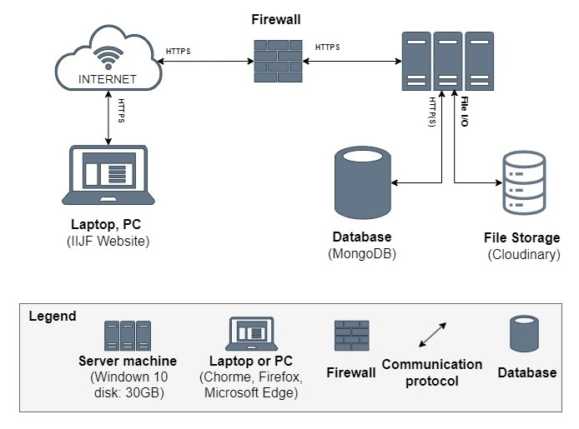

**Figure 4:** *Allocation View for Intelligence IT Job Finding*

**Prose**

|  |  |
| --- | --- |
| **Element** | **Responsibilities** |
| Laptop or PC | Device running browser and helping Admin, Employer and Candidate to use the functions of the website to manage. |
| Backend Server | Provide an API to support the interaction between the user interface and the server. where to install and run the backend API |
| Firewall | Firewall systems are used to protect the system from intrusive activities and control network traffic entering and leaving the system. |
| Internet | A network that connects devices together and allows access to online services and resources. |
| File Storage | Where files and data used by the system are stored, such as documents, images, videos, files uploaded by users. |
| MongoDB Database | The place contains all data about tours, user information,... It is organized in collection and document |

**Description**

The system is deployed on and web environment (using ReactJS Framework). They interact with the server through APIs and WebSocket to read and write data from the MongoDB database. In addition, the system integrating with Dialogflow to design conversations for chatbot and VNPay supports for online payments

## **3.6 Workflow of Chatbot**

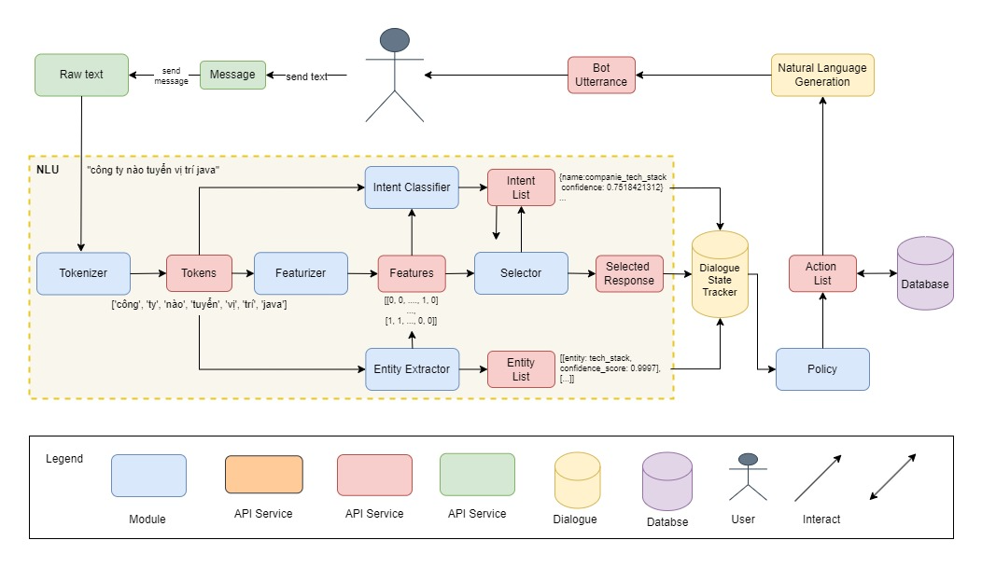

**Figure 5:** *Workflow of Chatbot for Intelligence IT Job Finding*

# ATAM

## 4.1 Present the ATAM

* Overall evaluation of system architecture documents, system designs on 3 views: static view, dynamic view, and physical view based on ATAM 9 Steps method.
* Expect to achieve an accurate and objective evaluation of the architectural document. From there, the project team assesses the ability to complete the project and achieve the Architecture Drivers.

## 4.2 Present the business Drivers

* The content on the document presented about the following:
  + Who are the business drivers.
  + Business problems and goals for the system are presented by the Project decision makers.
  + System’s features.
  + System’s requirements.
  + Project constraints.
  + Project scope.

## 4.3 Present the Architecture

* Current Architecture state: The design is systematically overviewed on all 3 views: allocation view, module view and component and connector view.
* Expected Architecture state: The architecture is easy to understand, easy to read, full of content, clear and responsive to the constraints and Quality Attributes of the system.
* Impact of following project constraints in the architecture:
  + Time / Deadline: Project will be finished in 98 days.
  + Cost / Available resources: 4 people with cost $2352
  + Complexity of the problem: high
  + Quality expectations: Meet the constraints and 4 Quality Attributes described above include: Security, Performance, Usability and Modifiability.

## 4.4 Identify the Architecture approaches

* Architecture pattern: Service-oriented architecture(SOA)
* In SOA, services use protocols that describe how they pass and parse messages using description metadata. This metadata describes both the functional characteristics of the service and quality-of-service characteristics. Service-oriented architecture aims to allow users to combine large chunks of functionality to form applications which are built purely from existing services and combining them in an ad hoc manner. A service presents a simple interface to the requester that abstracts away the underlying complexity acting as a black box. Further users can also access these independent services without any knowledge of their internal implementation
* The architectural blueprints are broken down into sections and interact with the services.

## 4.5 Create a Quality Attribute Tree

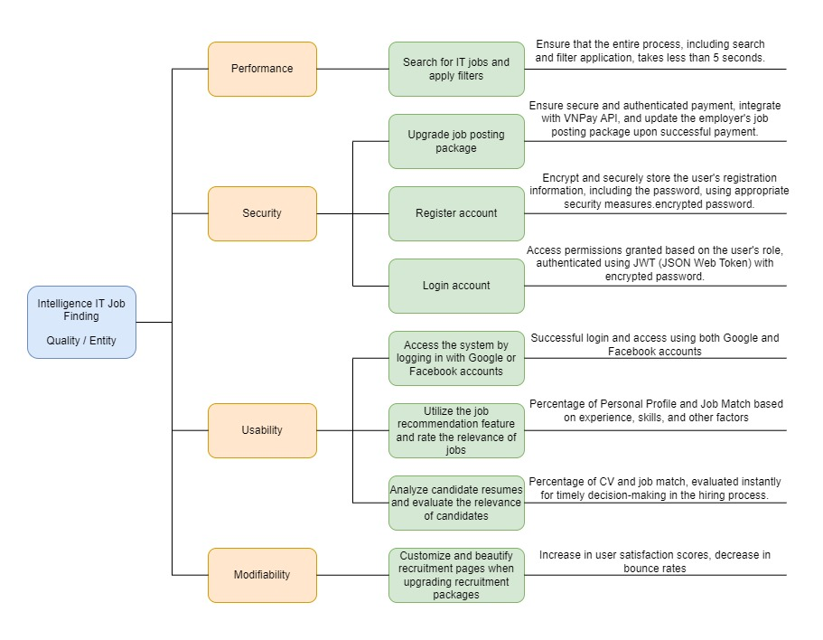

**Figure 6:** *Quality Attribute Tree for Intelligence IT Job Finding*

## 4.6 Analyze the Architectural approaches

|  |  |
| --- | --- |
|  | **Evaluate** |
| **Tradeoffs** | * Performance vs Load: Increased search and registry processing performance can increase load and system resource requirements. * User Experience vs Security: Complex user interfaces can improve experience, but also increase security risks. |
| **Sensitivity points** | * Personal information and certifications: Personal data and IT skills need to be protected. * Measurement and evaluation: The accuracy of evaluation tools is a sensitive point. * Interaction with HR systems: Linking with HR systems creates sensitive points of access and data. |
| **Risk and non-risk scenarios** | * Cyber attack: Risk of loss of security and hacker attacks. * System errors: Technical problems can cause disruption and frustration for candidates. * Legal compliance: Legal risks and loss of reputation if you do not comply with regulations. |

## 4.7 Brainstorm and prioritize scenarios

* Rank priority based on the constraints and attributes(descending):
  + Performance
  + Security
  + Usability
  + Modifiability

## 4.8 Re-analyze the architectural approaches

* Validate with the system architect to discover and achieve with the system design.

## 4.9 Present the results

* Based on the above reviews:
  + The system can accommodate a number of Quality Attributes and constraints given.
  + However, some systemic risks will appear affecting the system and the Quality Attributes will be in order of priority.

# References

|  |  |  |
| --- | --- | --- |
| **No.** | **References** | **Document Information** |
| 1 | Design standards,  Document standards | https://www.softwarearchitecturebook.com/svn/main/slides/ppt/26_Standards.ppt |
| https://standards.ieee.org/standard/1471-2000.html |
| https://ieeexplore.ieee.org/document/917550 |
| 2 | Patterns | https://en.wikipedia.org/wiki/Architectural_pattern |
| 3. | Evaluation standards | https://www.iso.org/obp/ui/#iso:std:iso-iec-ieee:42030:ed-1:v1:en |
| https://gabrielfs7.github.io/software-architecture/2019/10/18/atam-analyze-evaluate-architecture/ |